

**DADES MUNICIPALS GRUP XX – (comarca)**

**Consultor: xxxx**

|  |  |  |  |  |  |  |  |  |  |  |  |
| --- | --- | --- | --- | --- | --- | --- | --- | --- | --- | --- | --- |
| **AJUNTAMENT** | **HABIT.** | **ALCALDE/SSA** | **SECRETARI/A MUNICIPAL** | **SECRETARI/A COMPARTIT AMB:** | **ARXIVER** | **REGISTRE EXPRÉS** | **SICALWIN** | **GDD** | **MODUL SUBVENCIONS** | **e-SET** | **CONNECT.** |
|  |  |  |  |  |  |  |  |  |  |  |  |
|  |  |  |  |  |  |  |  |  |  |  |  |
|  |  |  |  |  |  |  |  |  |  |  |  |
|  |  |  |  |  |  |  |  |  |  |  |  |

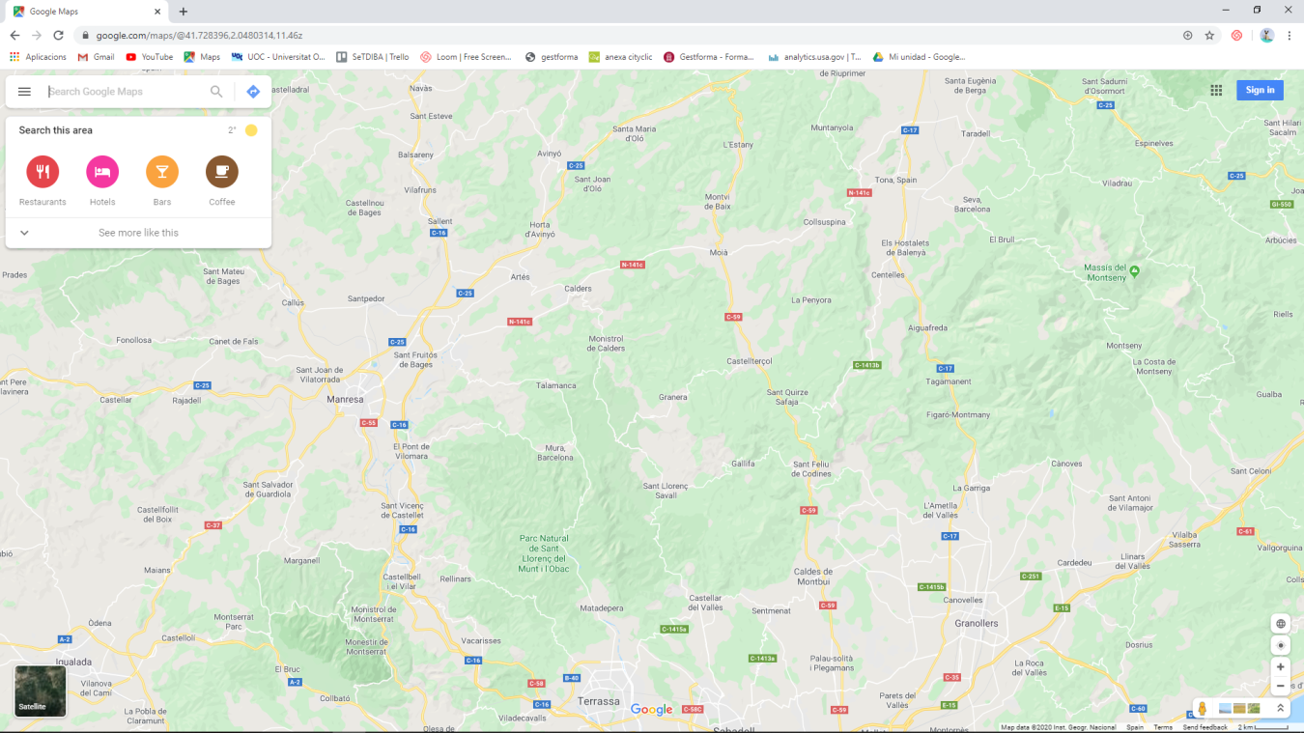

**MAPA CORRESPONENT:**